**LAB Q1**

1. Port 20 has been used to open a secured connection whereas Port 21 is used to transmit the file.
2. 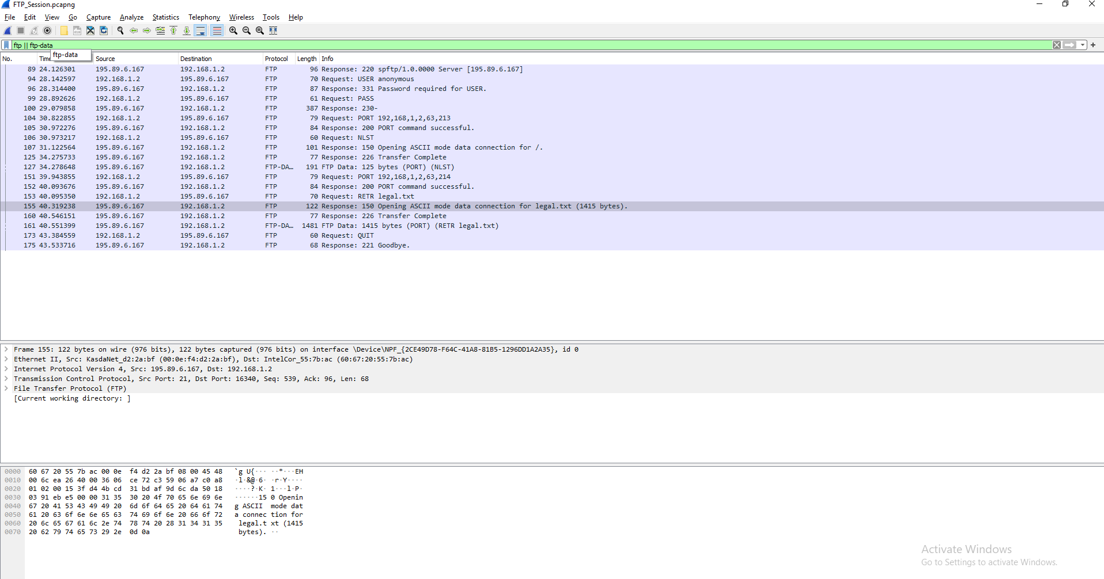 **89 – Server response has been received as FTP 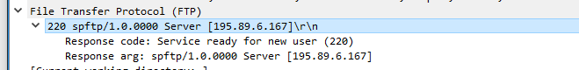 94 – Request is being made from the server.** 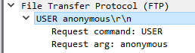  
   **96 – Server response has been received as FTP** 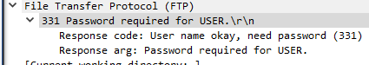  
   **99 – Request is being made from the server**   
   **100 - Response** 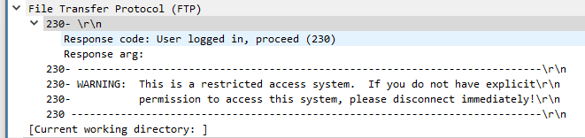  
    **104 – Request 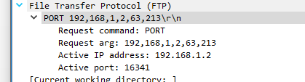 105 – Response 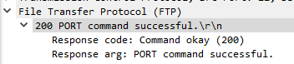 106 – Request**  **107 – Response 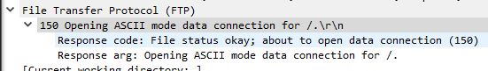 125 – Response 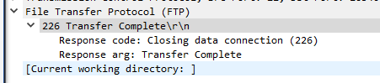 127 – Data file is being recieved** 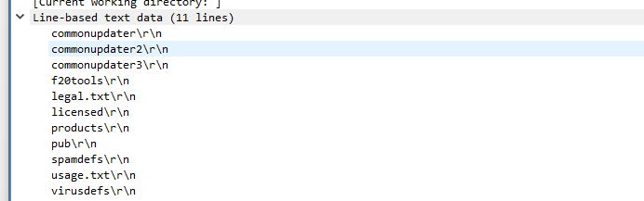  
    **151 – Request 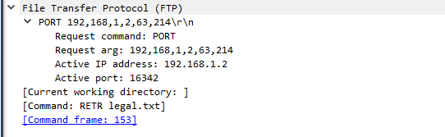 152 – Response 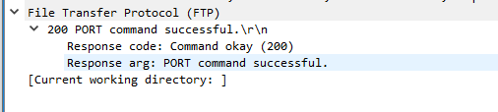 153 – Request 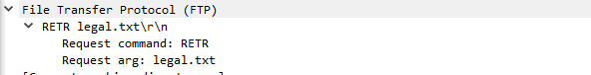 155 – Response** 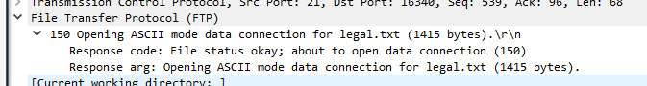  
   **160 – Response 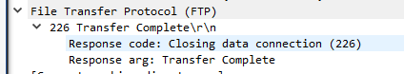 161 – Data file is being received** 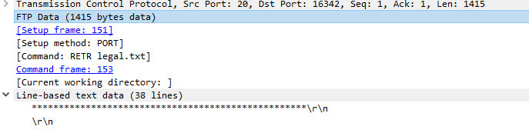  
    **173 – Request 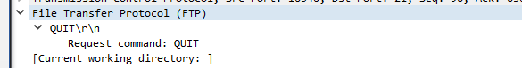 175 – Response** 